**DAILY ONLINE ACTIVITIES SUMMARY**

|  |  |  |  |  |  |  |  |  |
| --- | --- | --- | --- | --- | --- | --- | --- | --- |
| **Date:** | **15-06-2020** | | | | | **Name:** | **Sneha K Bakale** | |
| **Sem & Sec** | **6th B** | | | | | **USN:** | **4al17cs095** | |
| **Online Test Summary** | | | | | | | | |
| **Subject** | | **Python (Workshop Assesment)** | | | | | | |
| **Max. Marks** | | **20** | | **Score** | | | **19** | |
| **Certification Course Summary** | | | | | | | | |
| **Course** | **Programming in C** Workshop on Applications of Python Programming in Data Analytics and Machine Learning | | | | | | | |
| **Certificate Provider** | | | **Mr.Vikek sharma**  **Dr.Badhusha** | | **Duration** | | | **4.0 hours** |
| **Coding Challenges** | | | | | | | | |
| **Problem Statement: 1.** **Exercise of c programming of placement training.**  **2.** **Python Programming in Data Analytics and Machine Learning exercise.** | | | | | | | | |
| **Status: Completed** | | | | | | | | |
| **Uploaded the report in Github** | | | | | **Yes** | | | |
| **If yes Repository name** | | | | | **Report-**[**https://github.com/Sneha35/OnlineCourse-And-Coding.git**](https://github.com/Sneha35/OnlineCourse-And-Coding.git)  **C programming-**  [**https://github.com/Sneha35/C-Programming.git**](https://github.com/Sneha35/C-Programming.git)  **Python Programming-**  [**https://github.com/Sneha35/Applications-of-python-programming-in-DA-and-ML.git**](https://github.com/Sneha35/Applications-of-python-programming-in-DA-and-ML.git) | | | |
| **Uploaded the report in slack** | | | | | **Yes** | | | |

Online Test Details: (Attach the snapshot and briefly write the report for the same) 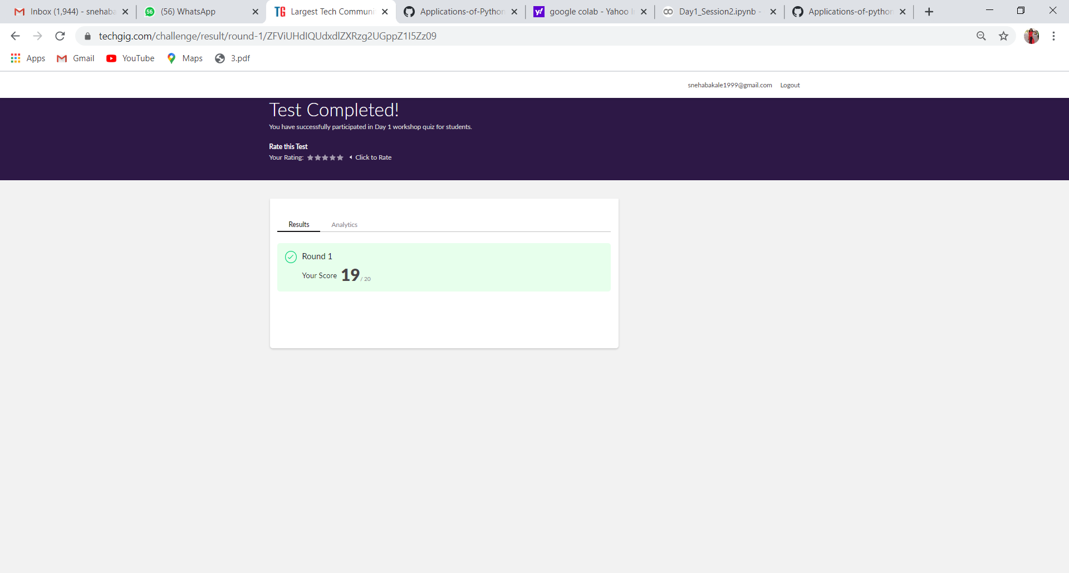

Certification Course Details: (Attach the snapshot and briefly write the report for the same) 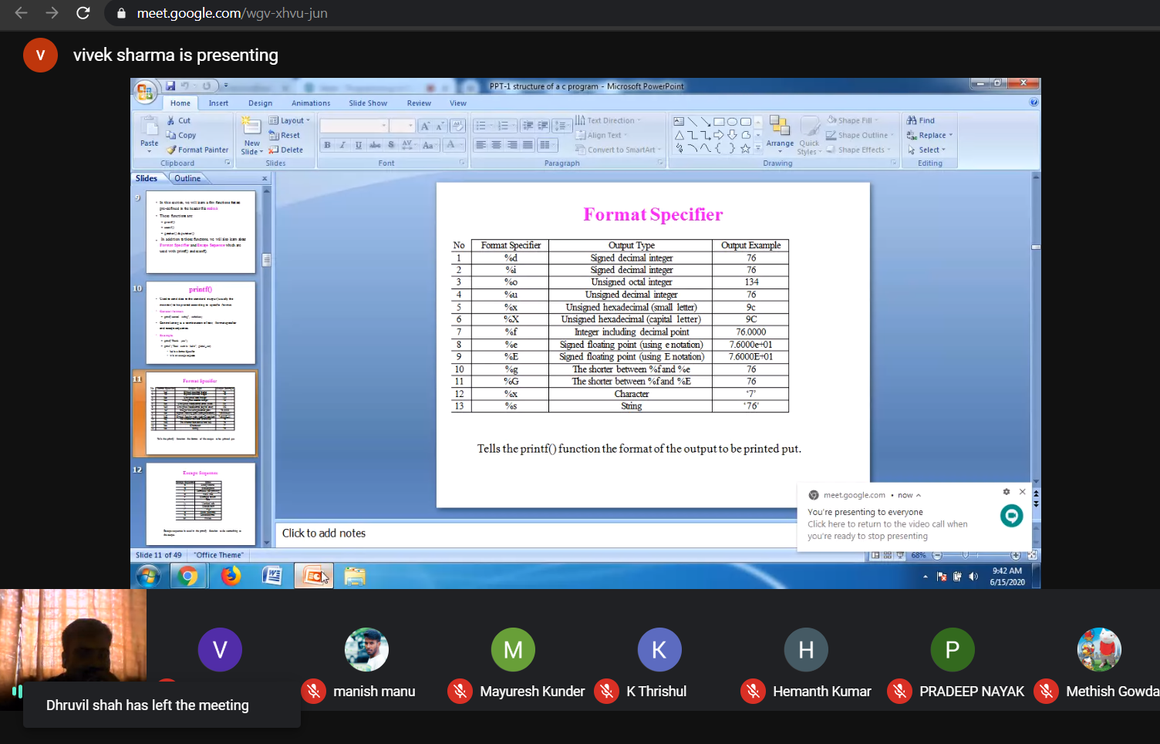

Coding Challenges Details: (Attach the snapshot and briefly write the report for the same) 